Create local file :



List local file under myFiles dir :



After copy contents on testFile.txt:

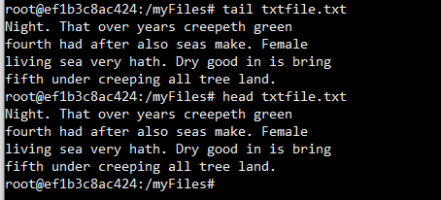

After copy contents for csv file

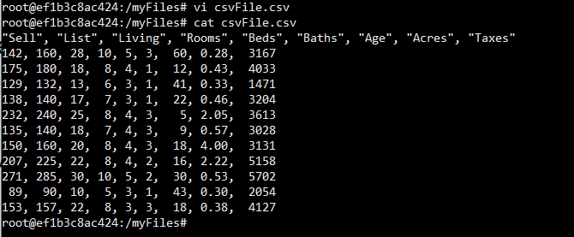

Dir created under HDFS:

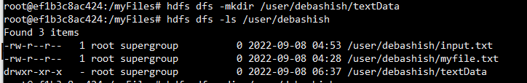

Copy the TXT file, **textFile.txt**, into the **textData folder** in the HDFS.

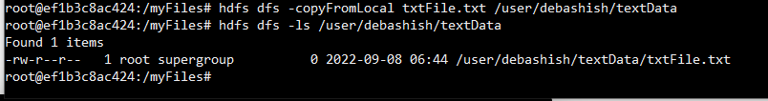

Copy the CSV file, **csvFile.csv**, into the **textData folder** in the HDFS.

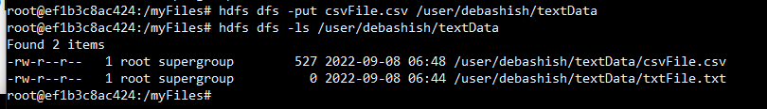

Finally use the **stat** command to get the file statistics:

